# 



**Snowell Electric**

**Documentation**

|  |  |
| --- | --- |
| **Authors** | **C2311L- Group 2** |
| **Student- Nguyen Tien Lam**  **Student- Dong Nhan Hiep**  **Student- Nguyen Manh Hung**  **Student- Pham Hoang Anh** |
| **Date** | **19/08/2024** |
| **Instructor** | **Ngo Trung Kien** |

Hanoi, 19/08/2024

**Index**

1. Problem Definition 4

1.1. Problem Abstraction 4

1.2. The Current System 4

1.3. The Proposed System 5

2. Customer Requirements Specification 6

2.1. Users of the System 6

2.2. System functions 7

2.2.1. Register 7

2.2.2. Log In 8

2.2.3. Home 12

2.2.4. Shop Categories 13

2.2.5. Product Detail Page 16

2.2.6. Related Product 17

2.2.7. Shopping Cart 18

2.2.8. Checkout 18

2.2.9. Thank you 19

2.2.10. Store Address 20

2.3. Admin 21

2.3.1. Dashboard 21

2.3.2. Category 23

2.3.3. Brand 26

2.3.4. Product 27

2.3.5. Logout 31

3. System Designs 31

3.1. Entity Relationship Diagram 31

3.2. Database Design 34

3.3. Sitemap 41

3.4. System fucntions design 42

3.4.1. Resgistration 42

3.4.2. Login 43

3.4.3. Checkout 44

4. Task sheet 45

5. Validation Checklists 48

# Problem Definition

## Problem Abstraction

In the age of rapid technological advancements and global connectivity, online platforms are playing an increasingly significant role in providing information and entertainment to users worldwide. Cosmic Wonders is a blog-style website that offers readers a space to explore captivating content related to astronomy, space exploration, and cosmic technology. Unlike e-commerce platforms or social networks, Cosmic Wonders focuses purely on providing information through articles and multimedia without requiring users to register or log in.

The motivation behind creating Cosmic Wonders arises from the growing interest in outer space, celestial events, and the ever-evolving technologies used in space exploration. As humanity reaches farther into the cosmos with missions to other planets and advancements in space technology, the public’s curiosity about the universe grows. Cosmic Wonders aims to satisfy this curiosity by providing a platform where users can read about space discoveries, upcoming celestial events, and the latest innovations in astronautical technology. The goal of the blog is to make this information easily accessible, engaging, and enjoyable for a wide audience of space enthusiasts.

## The Current System

The Cosmic Wonders website is designed with a simple and user-friendly interface to offer a seamless reading experience. The header includes a logo, navigation bar, and a visually engaging video that plays automatically when users visit the site. The navigation bar contains links to various sections of the blog:

* **Home**: Takes users back to the main page of the blog.
* **Event**: Features articles and updates about upcoming celestial events, such as meteor showers, eclipses, and planet alignments.
* **Celestial**: Focuses on astronomical phenomena and deep space objects like stars, galaxies, and black holes.
* **Cosmotechnology**: Explores the latest advancements in space technology, such as satellite innovations, space missions, and astronautical tools.
* **Astronaut**: Provides stories about astronauts, their journeys, and the human experience of space travel.

The header includes a captivating video banner that immerses users in the cosmic theme. This video, set against an overlay, serves as the first point of engagement. Below the header, the blog’s latest posts and featured articles are displayed. Scrolling through the blog, users encounter well-organized sections with informative articles and high-resolution images that illustrate the wonders of space. The website is fully responsive and accessible across various devices and browsers, ensuring that space enthusiasts can enjoy the content from any platform.

## The Proposed System

The goal of Cosmic Wonders is to continuously provide readers with high-quality content and improve their browsing experience without unnecessary distractions like account registration or login. The blog's layout is structured to enhance user engagement, with a strong focus on navigation simplicity and accessibility. The following are key features of the website:

* **Navigation Bar**: Users can easily explore different sections of the blog, such as upcoming events, technological advancements, and space exploration stories. The minimalist design of the navbar ensures that readers can find content without being overwhelmed by choices.
* **Search Functionality**: Although the website does not have a built-in search bar, users can intuitively navigate the site using clear category labels, ensuring easy access to articles.
* **Cosmic-Themed Design**: The homepage features a dynamic video header that draws users into the theme of space exploration. Below the video, curated articles appear in a blog-roll format, making it easy to find the latest or featured posts.
* **Multimedia Support**: Each blog post is enriched with images, videos, and infographics related to space and technology, enhancing the user experience and providing visual engagement alongside written content.
* **Responsive Design**: The blog is optimized for both mobile and desktop platforms, ensuring a consistent and enjoyable experience for all users, whether they are browsing on a smartphone, tablet, or computer.
* **No Account Requirement**: Readers can enjoy all the content without the need for registration, login, or passwords. This keeps the focus on delivering valuable information and eliminates any potential barriers to access.

In conclusion, Cosmic Wonders is designed to be an immersive, content-rich blog that delivers the latest news and discoveries in astronomy and space exploration. Its minimalist and responsive design ensures that users can easily browse articles on any device, making space-related knowledge accessible and engaging for everyone.

# Customer Requirements Specification

## Users of the System

* **Readers**: Individuals visiting the site to explore and read blog content.
* **Site Administrator**: Manages the content, categories, and overall website settings.
* **Site Administrator**: Manages the content, categories, and overall website settings.

Features Provided to Users:

* **Browsing Blog Posts**: Users can easily explore various blog posts categorized for better navigation.
* **Reading Articles**: Access detailed articles that cover different topics of interest.
* **User-Friendly Layout**: The website provides a clean, intuitive layout, making it easy for visitors to access the content.
* **Post Interactions**: Read, share, or save blog posts for later (sharing options like social media or bookmarks could be implemented in the future).
* **Search by Tags/Categories**: Although currently not present, this can be a potential addition to enhance content discovery based on user interest.
* **Content Updates**: Blog administrators can frequently update or add new articles.

## System functions

### Event

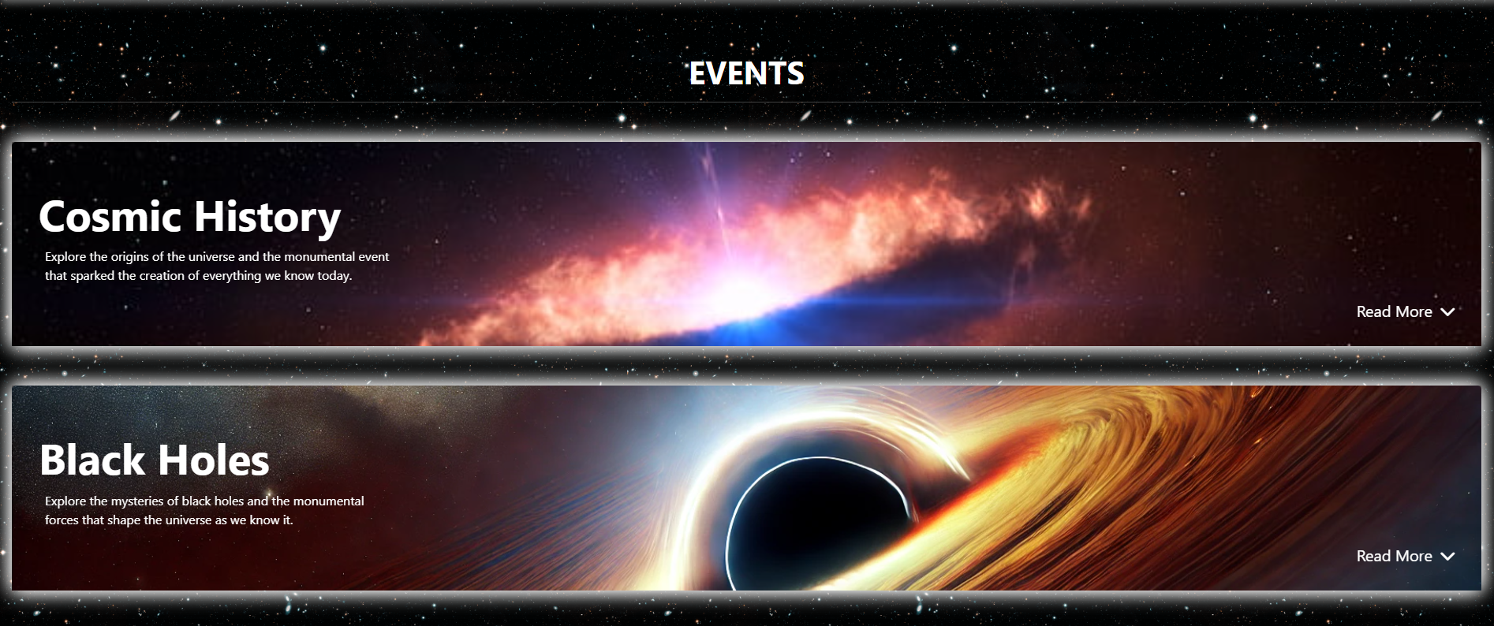

The **Events** section on our website opens the door to the deepest mysteries of the universe. Here, you can dive into extraordinary cosmic events, from the moment the universe was born to the captivating scientific phenomena that astronomers and physicists are still uncovering. Each event is carefully designed with a clear layout, accessible structure, and rich content to give you a comprehensive understanding of the universe’s history and the wonders that lie ahead.

The first topic, **Cosmic History**, will take you back to the early days of the universe, when all matter and energy were created from the greatest event of all – the **Big Bang**. You will explore how the universe expanded in its first moments and what happened immediately after, through phenomena like **Cosmic Inflation** and **Nucleosynthesis** – the era when the first elements like hydrogen and helium were formed.

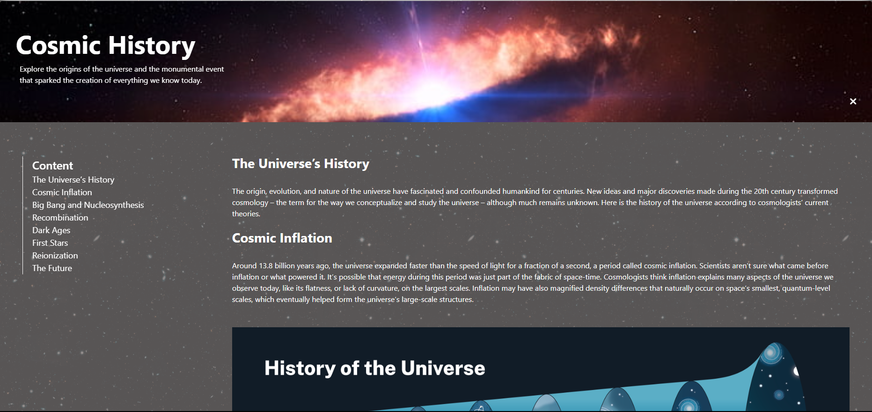

By clicking the "Read More" button, you will unlock detailed insights into the process of **Recombination**, when the first atoms began to combine, ushering in a new era where light could travel across space. This marked a critical turning point in shaping the universe as we know it today. Additionally, you’ll discover the **Dark Ages**, a period spanning hundreds of millions of years when no stars had yet formed, followed by the dramatic emergence of the **First Stars** and the first galaxies.

Furthermore, the events section will guide you to look toward the future of the universe through the predictions of scientists. The universe might continue to expand indefinitely, and one day, significant changes could occur due to the influence of **dark energy** – a mystery yet to be fully understood.

Each event is enhanced with visually engaging and dynamic illustrations, making it easier for you to imagine and experience the monumental processes that have shaped the universe we live in. The provided links allow you to navigate and delve deeper into complex concepts, expanding your knowledge from fundamental ideas to the latest scientific discoveries.

The **Events** section is not only a place to explore the events of the past but also an open space for you to learn about the future of the universe. Blending science with fascinating stories of how everything came to be, this section will help you uncover the wondrous aspects that science has revealed and continues to explore.

### Celestial: Stories of the Stars and Planets

Welcome to the **Celestial** section, where the wonders of the universe come to life through captivating stories about stars and planets. This space is specifically designed for those who are curious about the cosmos, offering a wealth of information and interactive features to enhance your exploration.

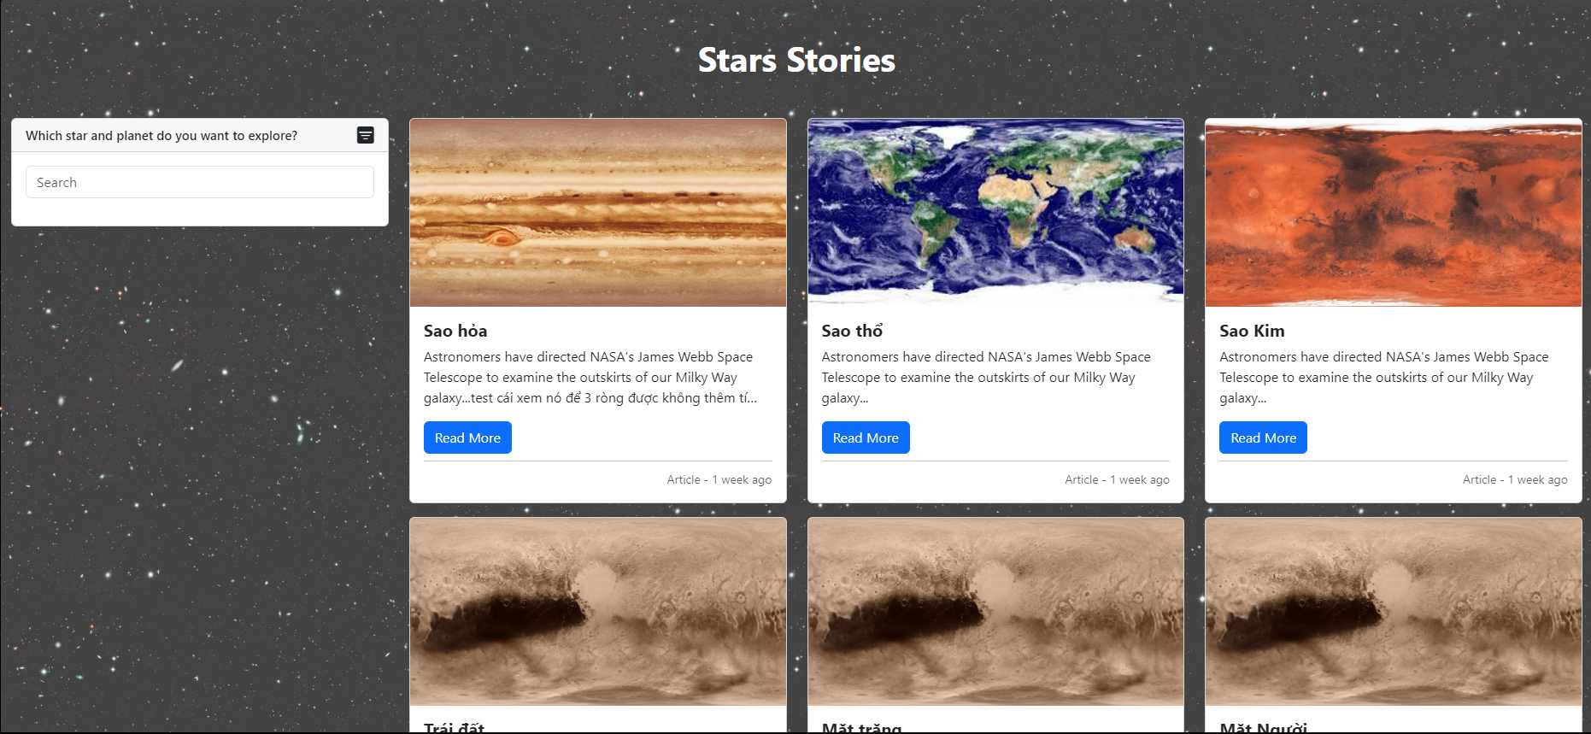

**Explore Celestial Bodies:** Users can browse through an extensive collection of articles focusing on various celestial entities. Whether you’re interested in the vibrant rings of Saturn, the intriguing characteristics of Mars, or the unique features of our own planet Earth, you'll find well-researched and engaging content that brings the mysteries of the universe closer to you.

**Interactive Filters and Search Options:** Our user-friendly interface allows you to easily navigate through the celestial content. You can utilize the search bar to quickly find specific articles or apply filters to narrow your choices by categories, such as planets or stars. This ensures that you can efficiently locate the information that piques your interest.

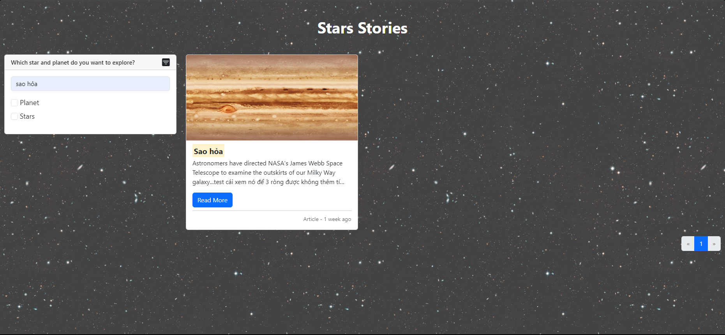

**Engaging Visuals and In-Depth Content:** Each article is accompanied by stunning imagery that captures the beauty of the cosmos. From breathtaking photos of planetary surfaces to artist renderings of distant galaxies, the visuals complement the informative text, providing a holistic learning experience. The articles are written in an accessible manner, making complex astronomical concepts easy to understand for readers of all levels.

**Read More Features:** For those who wish to dive deeper, our "Read More" feature allows you to access detailed content about specific celestial bodies. These articles provide comprehensive insights into their history, discovery, atmospheric conditions, and much more.

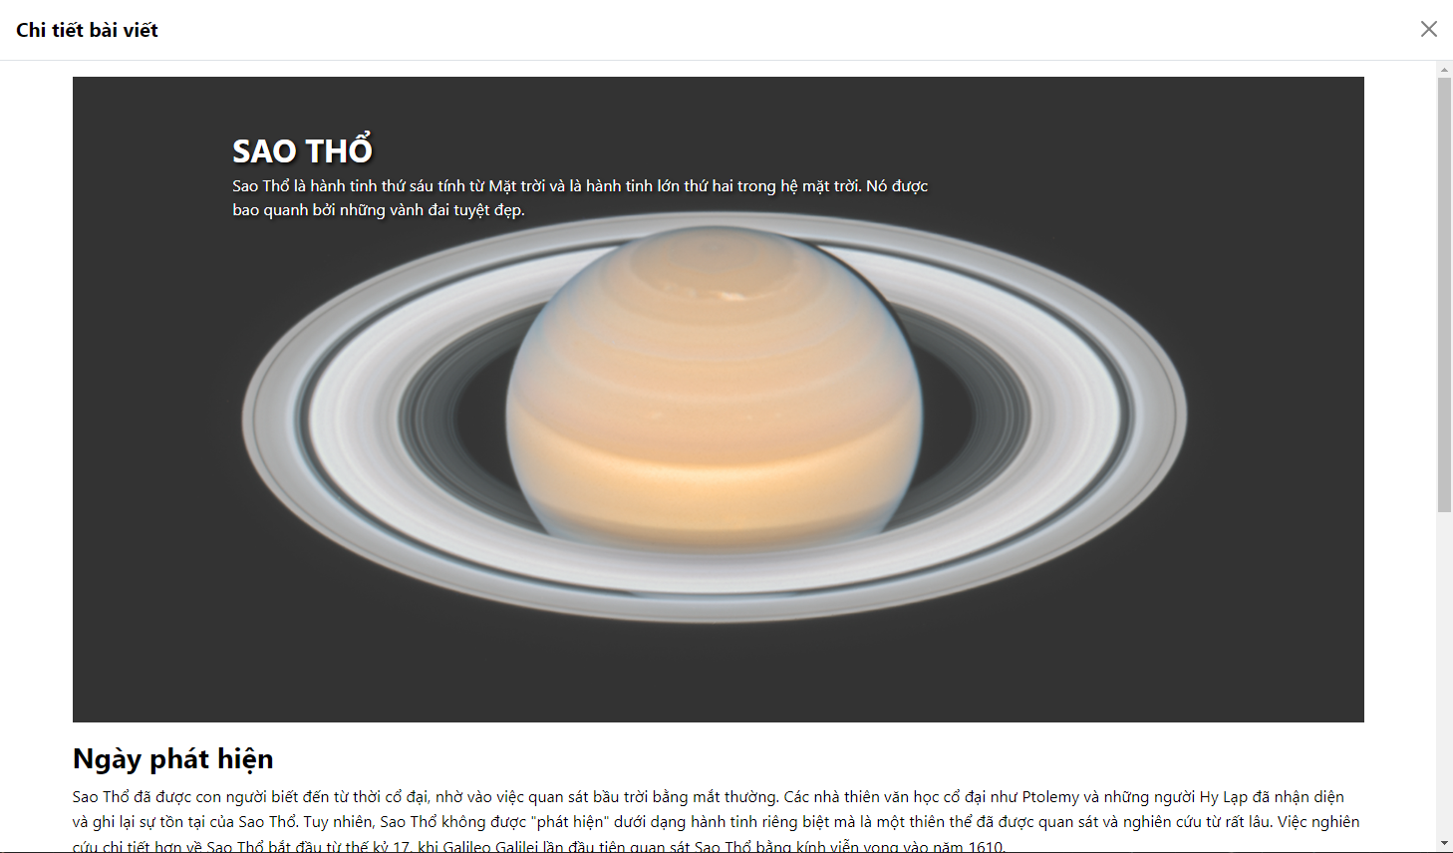

**Stay Updated with Latest Discoveries:** The **Celestial** section also keeps you informed about the latest discoveries and research in astronomy. With articles updated regularly, you'll always have access to the most current findings from the world of space exploration, including missions conducted by NASA and other astronomical organizations.

In summary, the **Celestial** section offers an enriching experience for users who wish to explore, learn, and connect with the wonders of the cosmos. Whether you're a seasoned astronomy buff or just beginning your journey into the stars, this space is your gateway to understanding the beauty and science of our universe.

### The Astronaut's Voyage to Explore the Stars

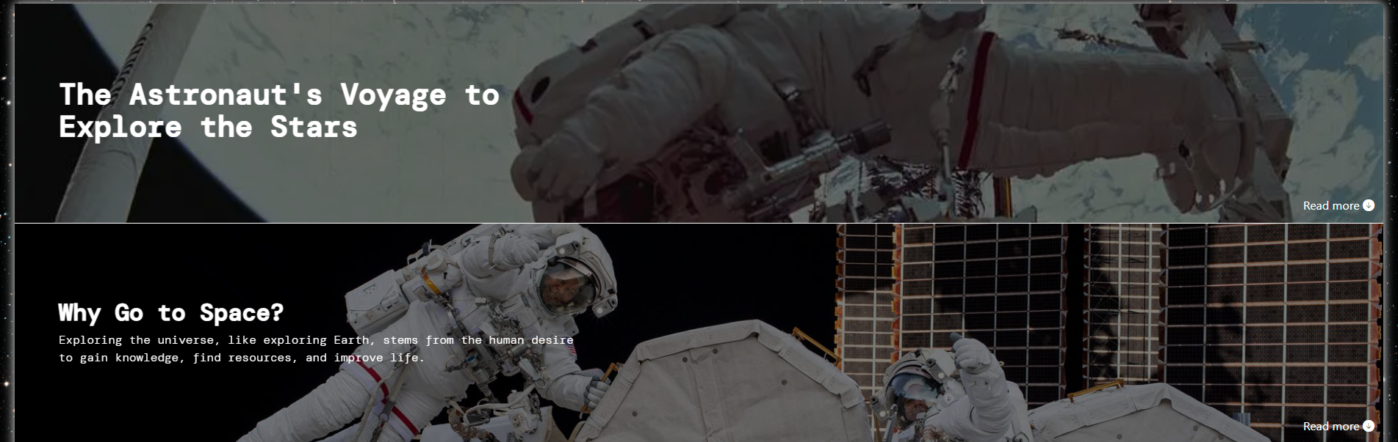

* **Summary**

The **The Astronaut's Voyage to Explore the Stars** section on our website serves as an interactive platform for space exploration enthusiasts. Here, users have the opportunity to learn about exciting destinations in space, engage in discussions about the significance of space exploration, and connect with like-minded individuals.

* **Introduction**  
  As humanity gradually expands its horizons beyond Earth, the exploration of space has become one of the most fascinating fields of our time. The **The Astronaut's Voyage to Explore the Stars** section not only provides information about space missions but also creates an interactive environment for users.
* **Interactive Capabilities**

Here, users can:

* **Explore Destinations**: Discover prominent destinations such as Earth, the Moon, and Mars. Through detailed information about the history, characteristics, and importance of each destination, users will gain insights into the challenges and opportunities of space exploration.
* **Participate in Discussions**: Users are encouraged to share their opinions and participate in discussions about why humanity seeks to explore space. From seeking new resources to addressing fundamental questions about existence, this section invites everyone to contribute their thoughts.
* **Comprehensive and Diverse Content**

Each section features a "Read More" option that allows users to easily access in-depth articles, research information, and the latest news about space. This not only helps expand knowledge but also creates opportunities for users to explore topics of interest

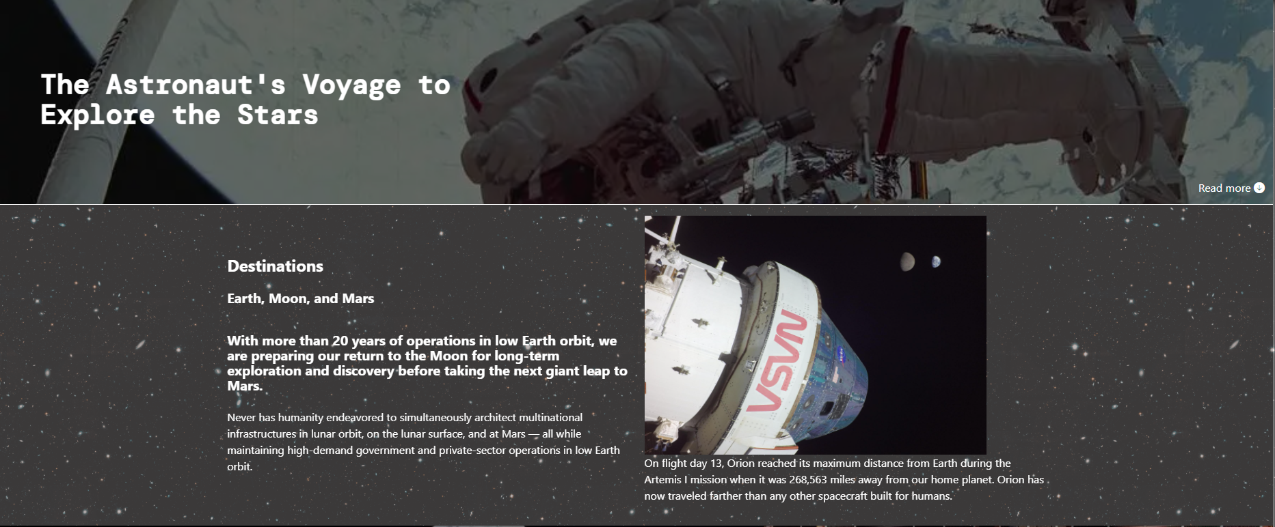

* **Engaging Illustrative Images**

We provide vibrant illustrative images of space missions, helping users visualize the experiences of scientists and astronauts in their journeys to explore the universe. These images not only enhance appeal but also enrich users' learning experiences.

* **Community Connection**

The **The Astronaut's Voyage to Explore the Stars** section is not just content; it’s a community of space enthusiasts. Users can connect with each other to share ideas, discuss new discoveries, and support one another in their quest to understand the wonders of the universe.

* **Conclusion**

**The Astronaut's Voyage to Explore the Stars** is a fantastic platform for anyone passionate about space exploration. We hope that through detailed information, illustrative images, and interactive capabilities, users will have engaging and enriching learning experiences. Join us in the journey to uncover the mysteries of the universe!

### Interactive Features in the "Spaceships and Rockets" Section

* **Objective**:

This section aims to provide detailed information about spaceships and rockets, particularly advancements in space technology developed by NASA. In addition to conveying knowledge, it also facilitates user interaction and engagement in the learning process.

* **Content:**
* Introduction to Rockets and Spaceships

This section begins with an overview of rockets, explaining the concept of a rocket and its role in transporting spacecraft from the Earth's surface to space. Factors such as mission objectives and rocket power are discussed, highlighting the diversity and complexity of different types of rockets.

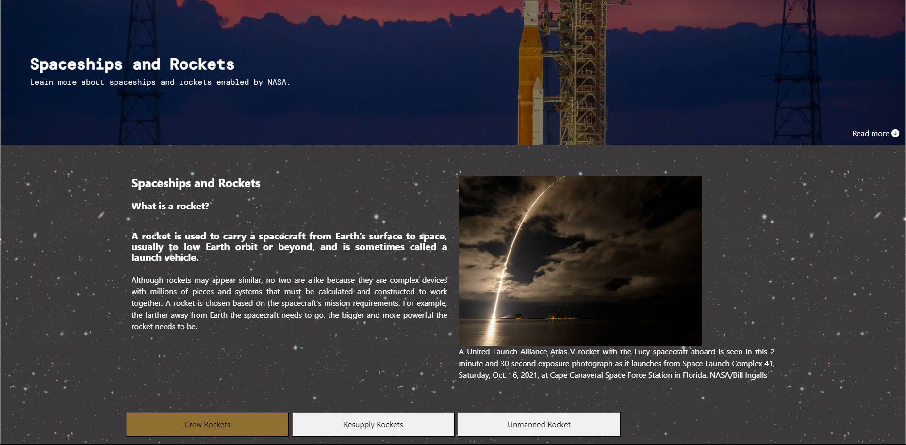

* Interactive Features
* **"Read more" Button**: This button allows users to learn more detailed information about rockets. Clicking the button expands the content, making it easy and convenient for users to access in-depth information.
* **Spaceship Categories**: Users can select different types of spacecraft through buttons. Categories such as **Crew Rockets**, **Resupply Rockets**, and **Unmanned Rockets** allow users to customize their learning experience according to personal interests. This not only adds enjoyment but also encourages users to explore more about each type of spacecraft.
* **Illustrative Images**: Each section is accompanied by actual images of launches, helping users visualize the size and scale of space missions. These images enhance the appeal and visual nature of the content.
* Detailed Information

Each type of rocket is presented with detailed information about its functions and missions. Users can learn about commercial rockets, resupply rockets, and unmanned rockets, thereby gaining a comprehensive understanding of the technology and applications of each type. This not only helps expand knowledge but also provides opportunities for users to explore different fields in space.

* Encouraging Community Interaction

This section does not stop at providing one-way information. It encourages users to participate in discussions, ask questions, and share opinions. This helps build a community of space enthusiasts, where like-minded individuals can interact and learn from each other.

* **Conclusion**:

The "Spaceships and Rockets" section serves as a platform that not only provides detailed information about space technology but also creates a rich interactive experience for users. By encouraging participation and exploration, this section truly becomes a valuable tool for educating and inspiring those passionate about exploring the universe.

### Report on Space Stations

* **Introduction:**

This report aims to provide an overview of various space stations, highlighting their significance in human space exploration and scientific research. From low Earth orbit to the Moon, space stations serve as crucial platforms for conducting experiments, fostering international cooperation, and advancing our understanding of life beyond Earth.

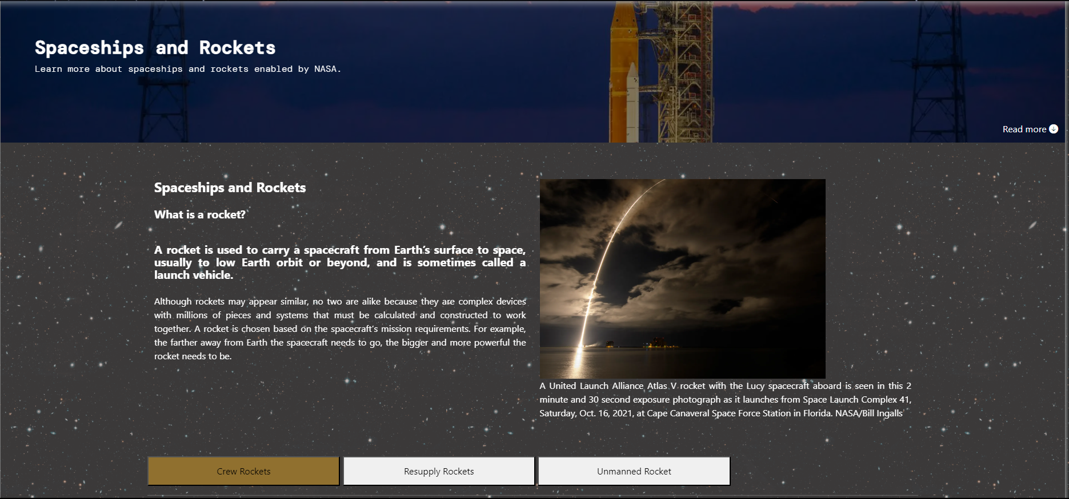

* **Overview of Space Stations:**

1. International Space Station (ISS):

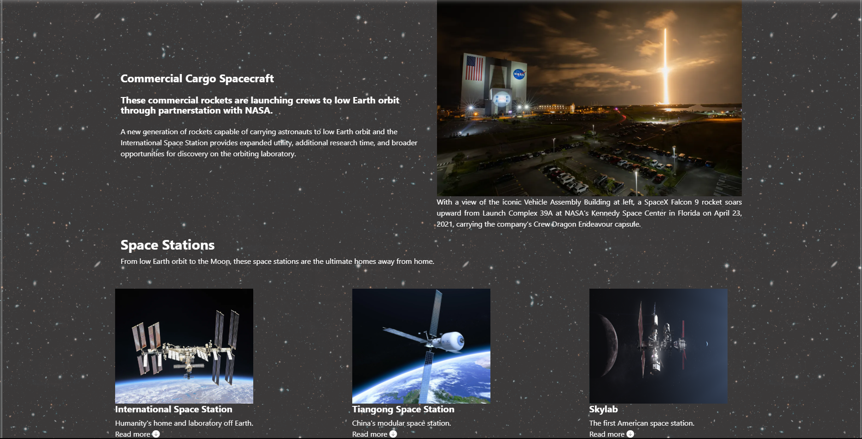

* + **Description**: The ISS is a habitable artificial satellite that orbits Earth and serves as a microgravity and space environment research laboratory.
  + **Significance**: It is a collaborative project involving multiple countries, including the United States, Russia, Japan, Canada, and the European Space Agency. The ISS is pivotal for research in various fields such as astrobiology, astronomy, and meteorology.
  + **User Interaction**: Visitors can click on the "Read more" link to access detailed information about the ISS, including its operational history, daily life for astronauts, and scientific contributions.

1. Tiangong Space Station:

* **Description**: The Tiangong space station is being constructed in low Earth orbit by China. It is designed to be modular, accommodating three astronauts and operational for a minimum of ten years.
* **Significance**: Tiangong represents China's growing capabilities in space exploration and its commitment to international collaboration in scientific endeavors.
* **User Interaction**: Users can engage with the "Read more" link to explore in-depth information about the Tiangong station's design, construction phases, and future missions.
* **User Interaction Features:**

The interactive features in this section enhance user engagement and information accessibility. Each space station includes a "Read more" link that triggers a modal window, providing comprehensive details about that specific station. This design ensures that users can easily navigate and explore the content without losing their place on the main page.

* **Modal Windows**: When users click the "Read more" link, a modal window opens, showcasing images and detailed descriptions. For example, the ISS modal includes information about its role in global scientific collaboration, while the Tiangong modal focuses on its innovative design and future operational plans.

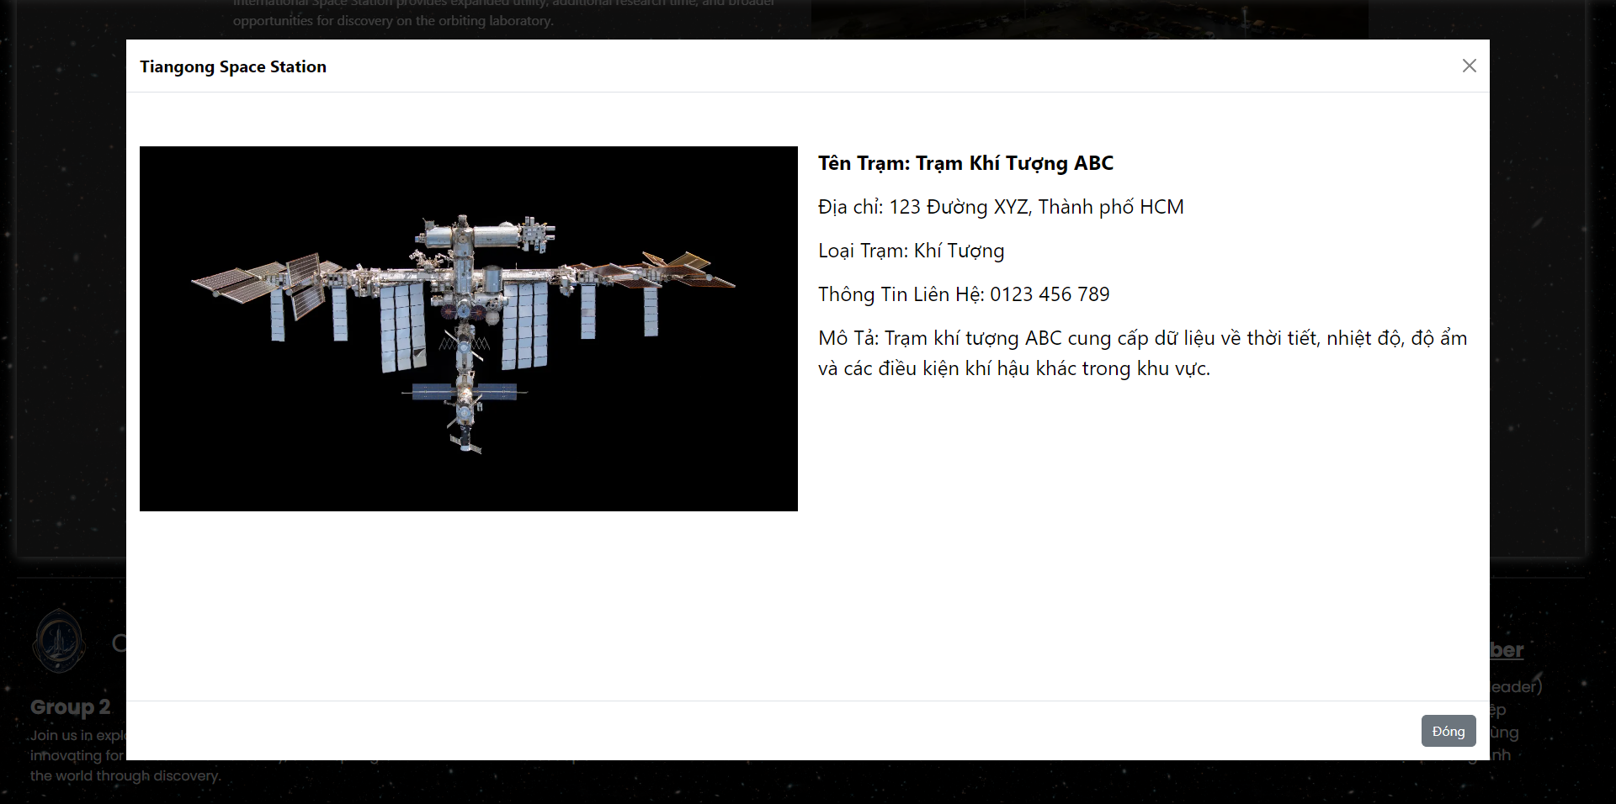

* **Visual Elements**: The use of high-quality images in conjunction with textual content creates an appealing visual experience, encouraging users to explore further and engage with the material.
* **Conclusion**

Space stations represent a significant leap in human ingenuity and collaboration. By providing an interactive platform for users to learn about these monumental structures, we enhance public interest and understanding of space exploration. The information presented in this report emphasizes the importance of space stations in scientific research and international cooperation, while the interactive features allow for an engaging user experience.

### Footer:

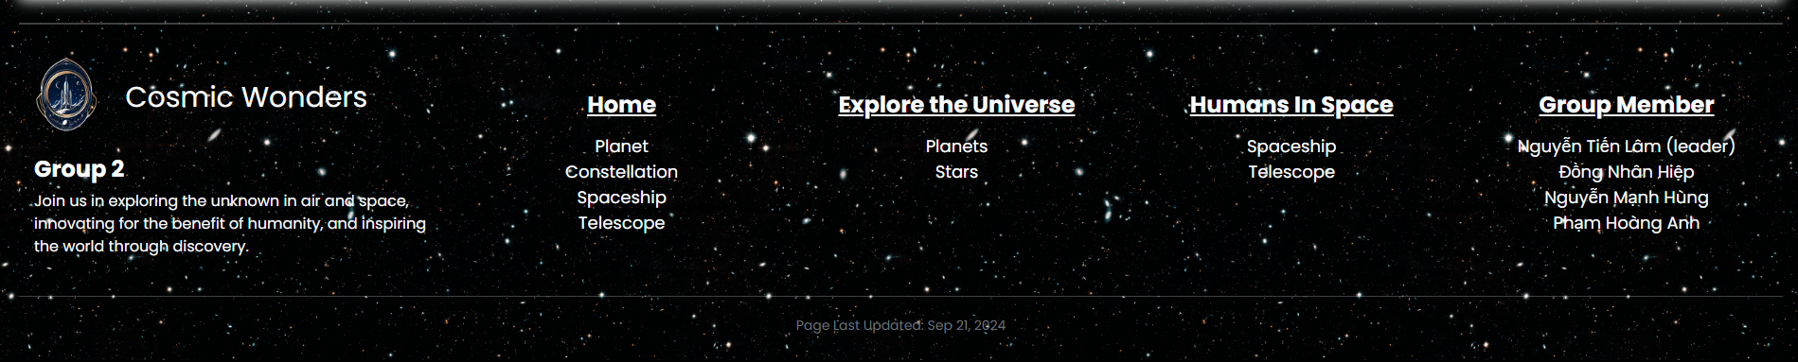

* **Introduction:**

The footer of the “Cosmic Wonders” website provides important information and useful links for users. It serves not only as a repository for details about the development team but also as a bridge for users to explore various content across the site. Below is a detailed analysis of the footer's components.

* **Structure and Content:**

1. Logo and Team Introduction

* **Logo**: The footer begins with the logo of the “Cosmic Wonders” team. This logo not only represents the brand but also creates a recognizable identity for users.
* **Introduction**: Next to the logo, there is a brief description of the team, highlighting their mission to explore space and innovate for the benefit of humanity. This helps build an emotional connection with users and demonstrates the team's commitment to exploration and discovery.

1. Important Links

* **Link Categories**: The footer is divided into several columns, each containing links related to different themes:
* **Home**: Links to pages such as "Planet," "Constellation," "Spaceship," and "Telescope." These links help users easily navigate to various sections of the website.
* **Explore the Universe**: Links to topics like "Planets" and "Stars," providing users with opportunities to learn more about the universe.
* **Humans In Space**: Links related to human exploration of space, such as "Spaceship" and "Telescope."
* **Group Member**: A list of the team members, including names and roles. This not only demonstrates transparency but also fosters a sense of closeness with users.
* **Conclusion:**

The footer of the “Cosmic Wonders” website is not merely a collection of links and information but an integral part of enhancing the user experience. With its intelligent design and meaningful content, the footer contributes to the website's usability while reflecting the vision and mission of the development team in exploring space and promoting innovation. The interactive elements in the footer facilitate easy access to information and create a seamless experience as users explore different aspects of the universe.

## Admin

### Dashboard

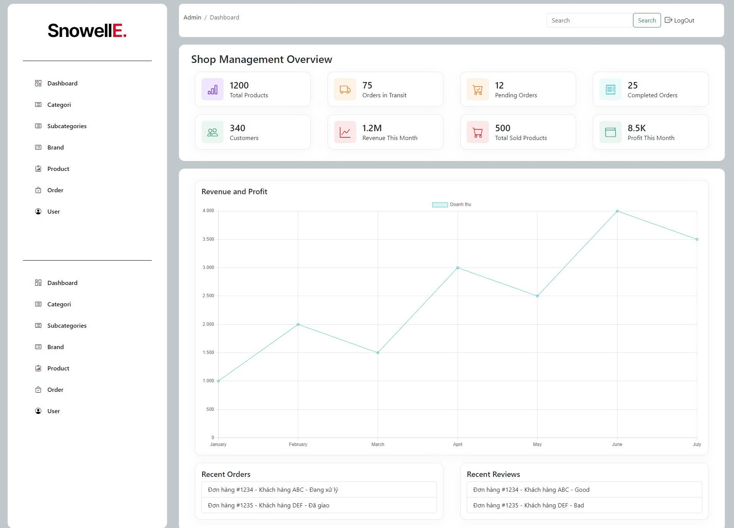

The dashboard shows:

1. **Shop Management Overview**
   * Total Products
   * Orders in Transit
   * Pending Orders
   * Completed Orders
   * Customers
   * Revenue This Month
   * Total Sold Products
   * Profit This Month
2. **Revenue and Profit**
   * Line chart showing revenue trends
3. **Recent Orders**
   * List of recent orders with status
4. **Recent Reviews**
   * List of recent customer reviews

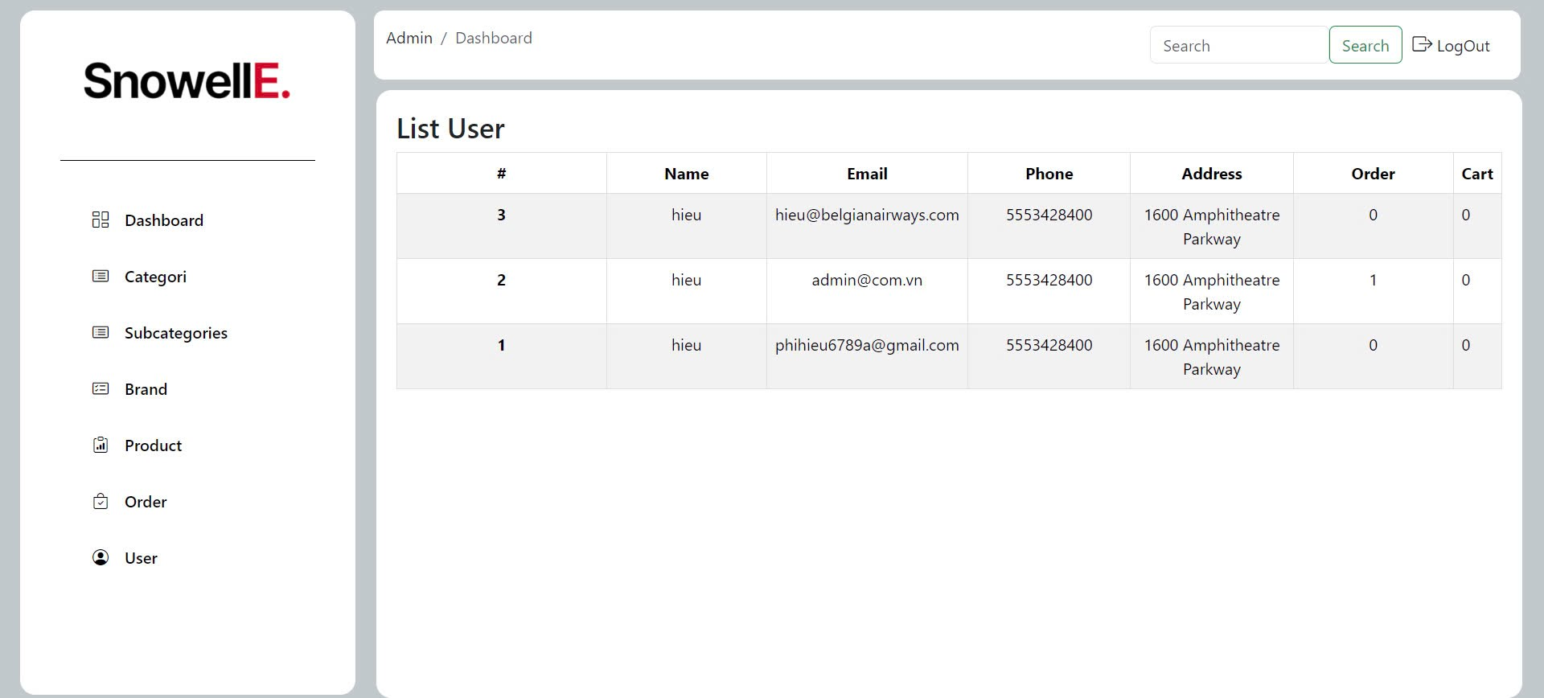

This interface shows:

**List User**:

**#**: User ID or rank.

**Name**: User's name.

**Email**: User's email address.

**Phone**: User's phone number.

**Address**: User's address.

**Order**: Number of orders placed by the user.

**Cart**: Number of items in the user's cart.

### Events

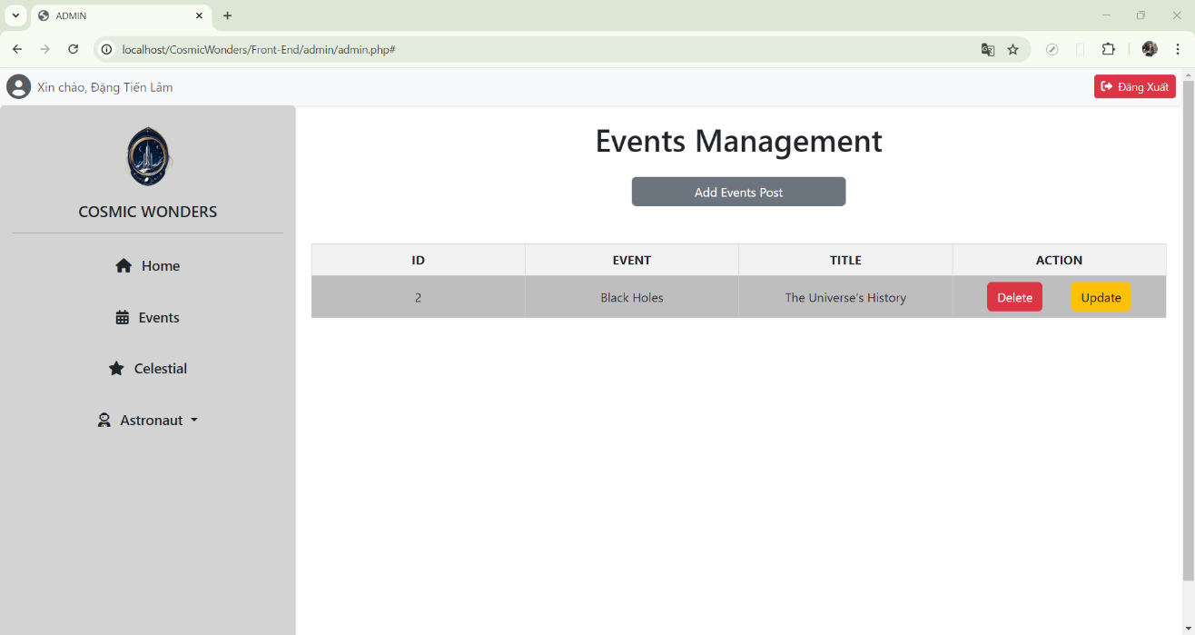

This category interface shows:

Add Category:

Input fields for "Category" and "Slug"

"**Add**" button to create a new category.

List Category:

Displays existing categories with columns for "Name" and "Slug".

Options to "Edit" and "Delete" each category.

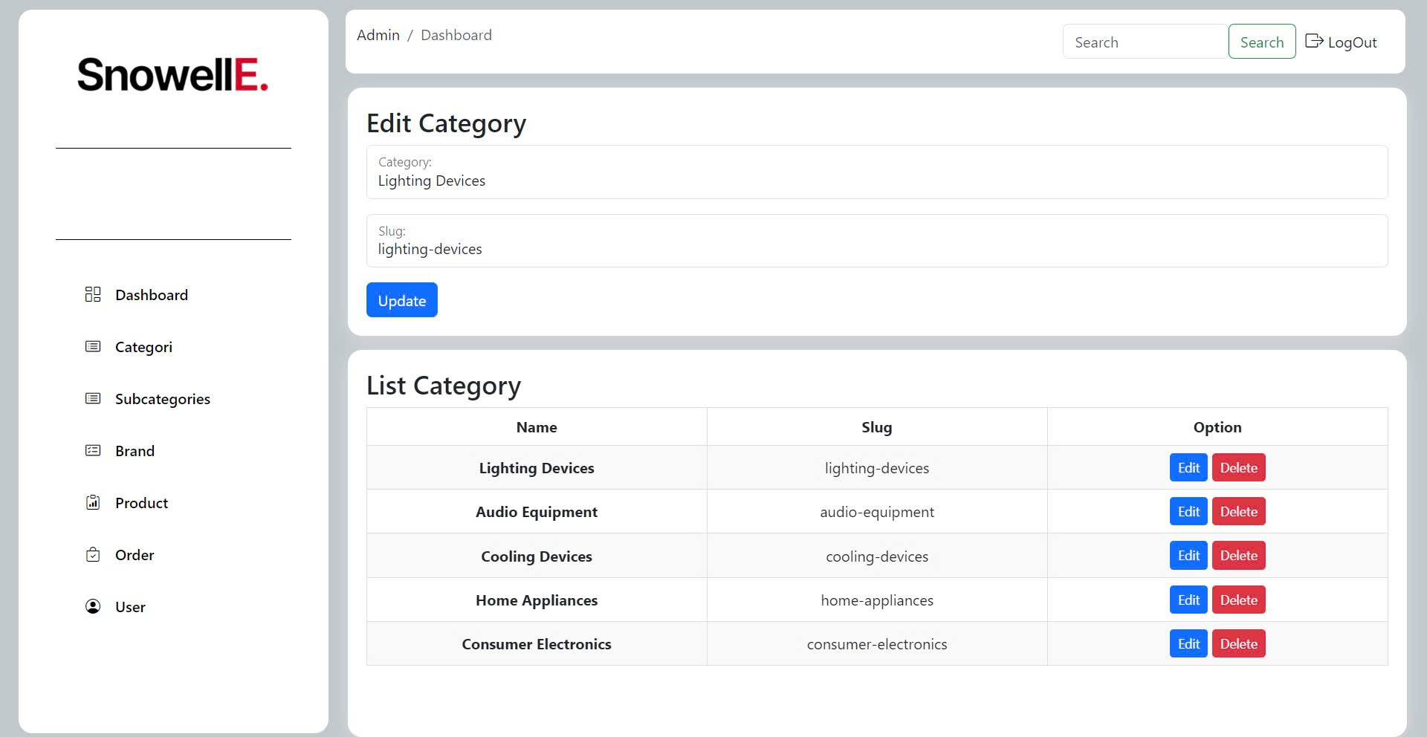

This interface shows:

**Edit Category**:

**Category**: Input field to enter the name of the category name.

**Slug:** Input field to enter or update the slug.

**Update Button** : Button to save changes.

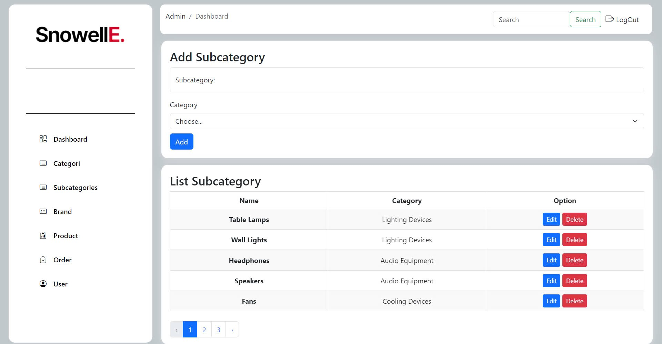

This interface shows:

**Add Subcategory**:

**Subcategory**: Input field to enter the name of the subcategory.

**Category**: Dropdown menu to select the main category to which the subcategory belongs.

**Add Button**: Button to add the new subcategory.

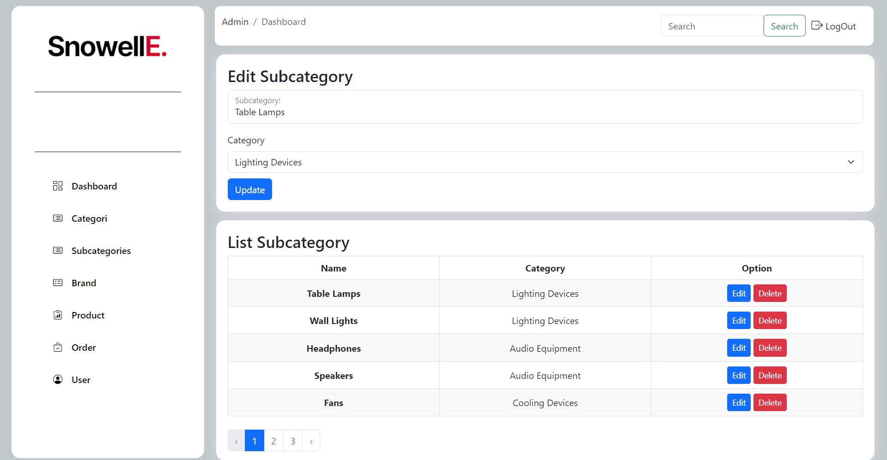

This interface shows:

**Edit Subcategory**

**Subcategory**: Input field to enter the name of the subcategory.

**Category**: Dropdown menu to select the main category to which the subcategory belongs.

**Update Button**: Button to save changes.

### Brand

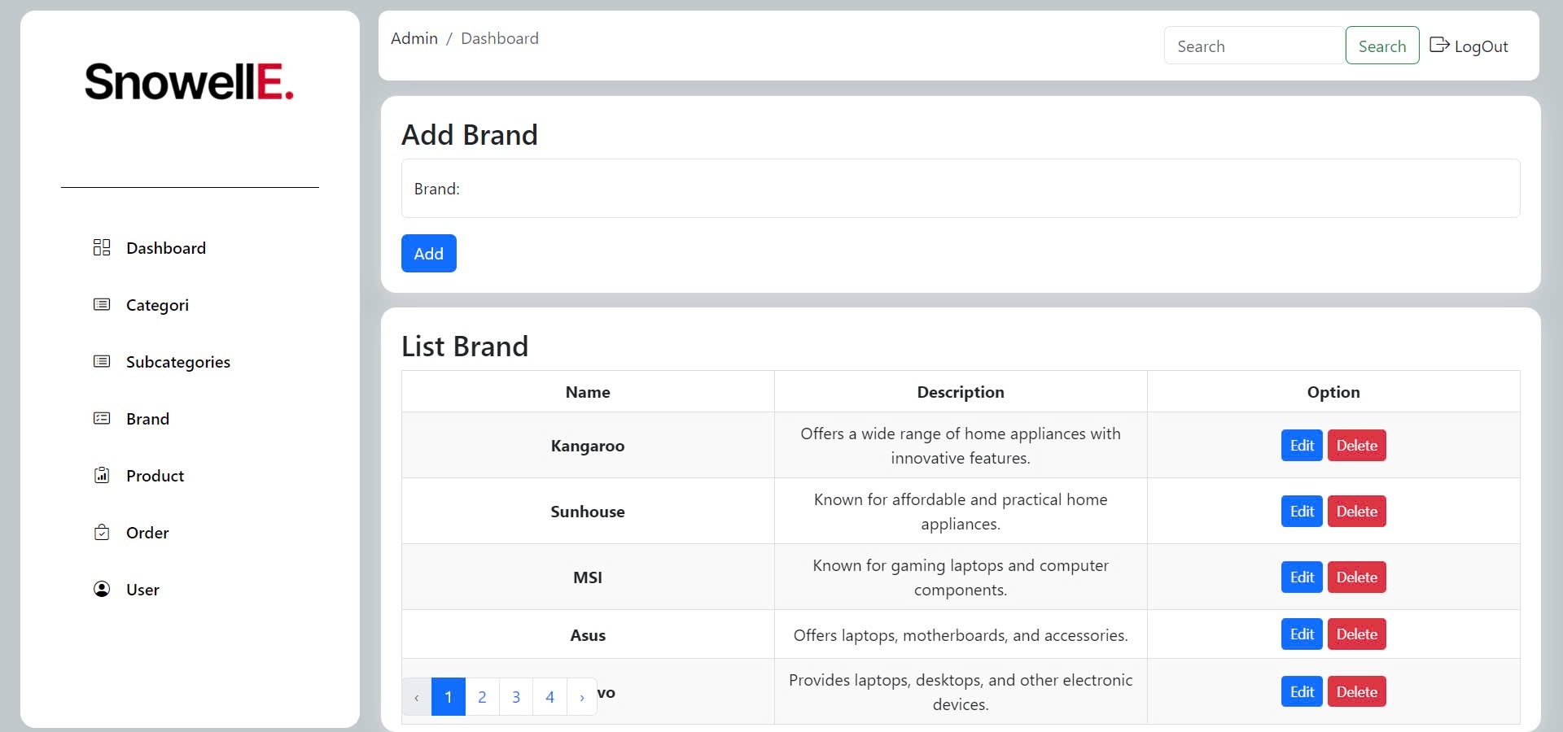

This interface shows:

**Add Brand**:

**Brand**: Input field to enter the brand name.

**Add Button**: Button to add the new brand.

**List Brand**:

**Name**: Name of the brand.

**Description**: Brief description of the brand.

**Option**: Buttons to "Edit" and "Delete" the brand.

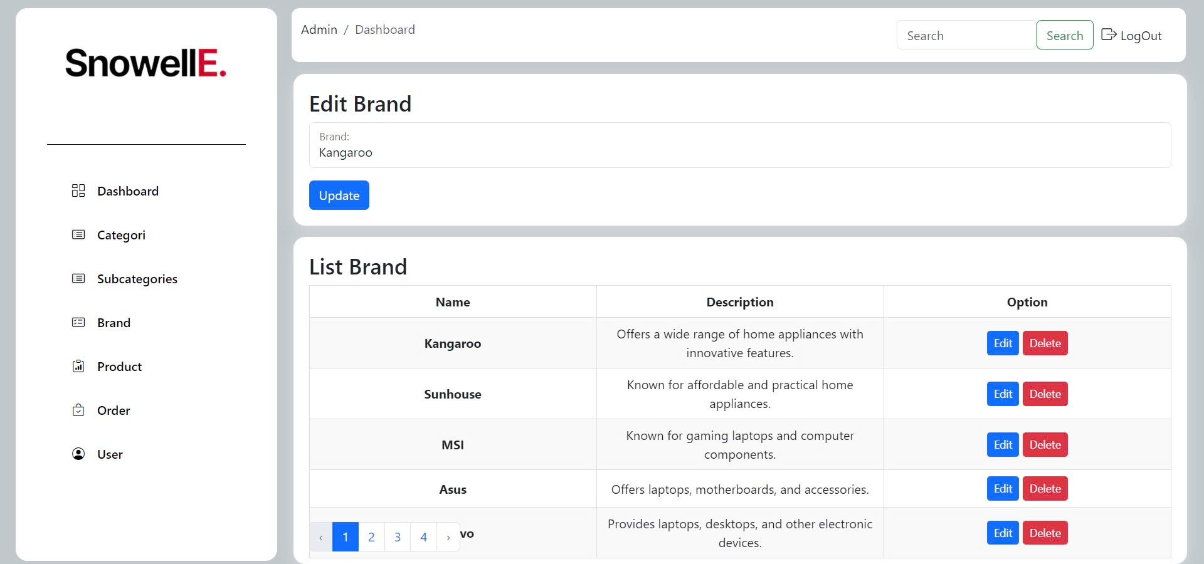

This interface shows:

**Edit Brand**:

**Brand**: Input field to enter or update the brand name.

**Update Button**: Button to save changes.

### Product

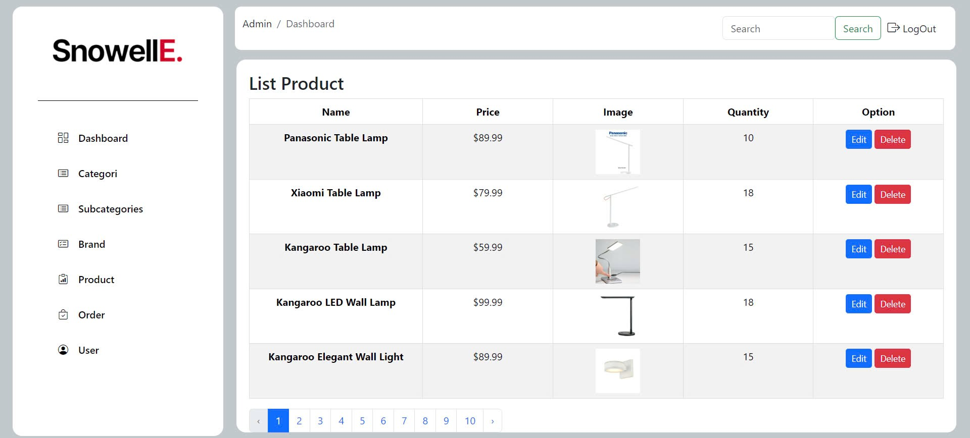

This interface shows:

**List Product**:

**Name**: Name of the product.

**Price**: Price of the product.

**Image**: Thumbnail image of the product.

**Quantity**: Number of items available in stock.

**Option**: Buttons to "Edit" and "Delete" the product.

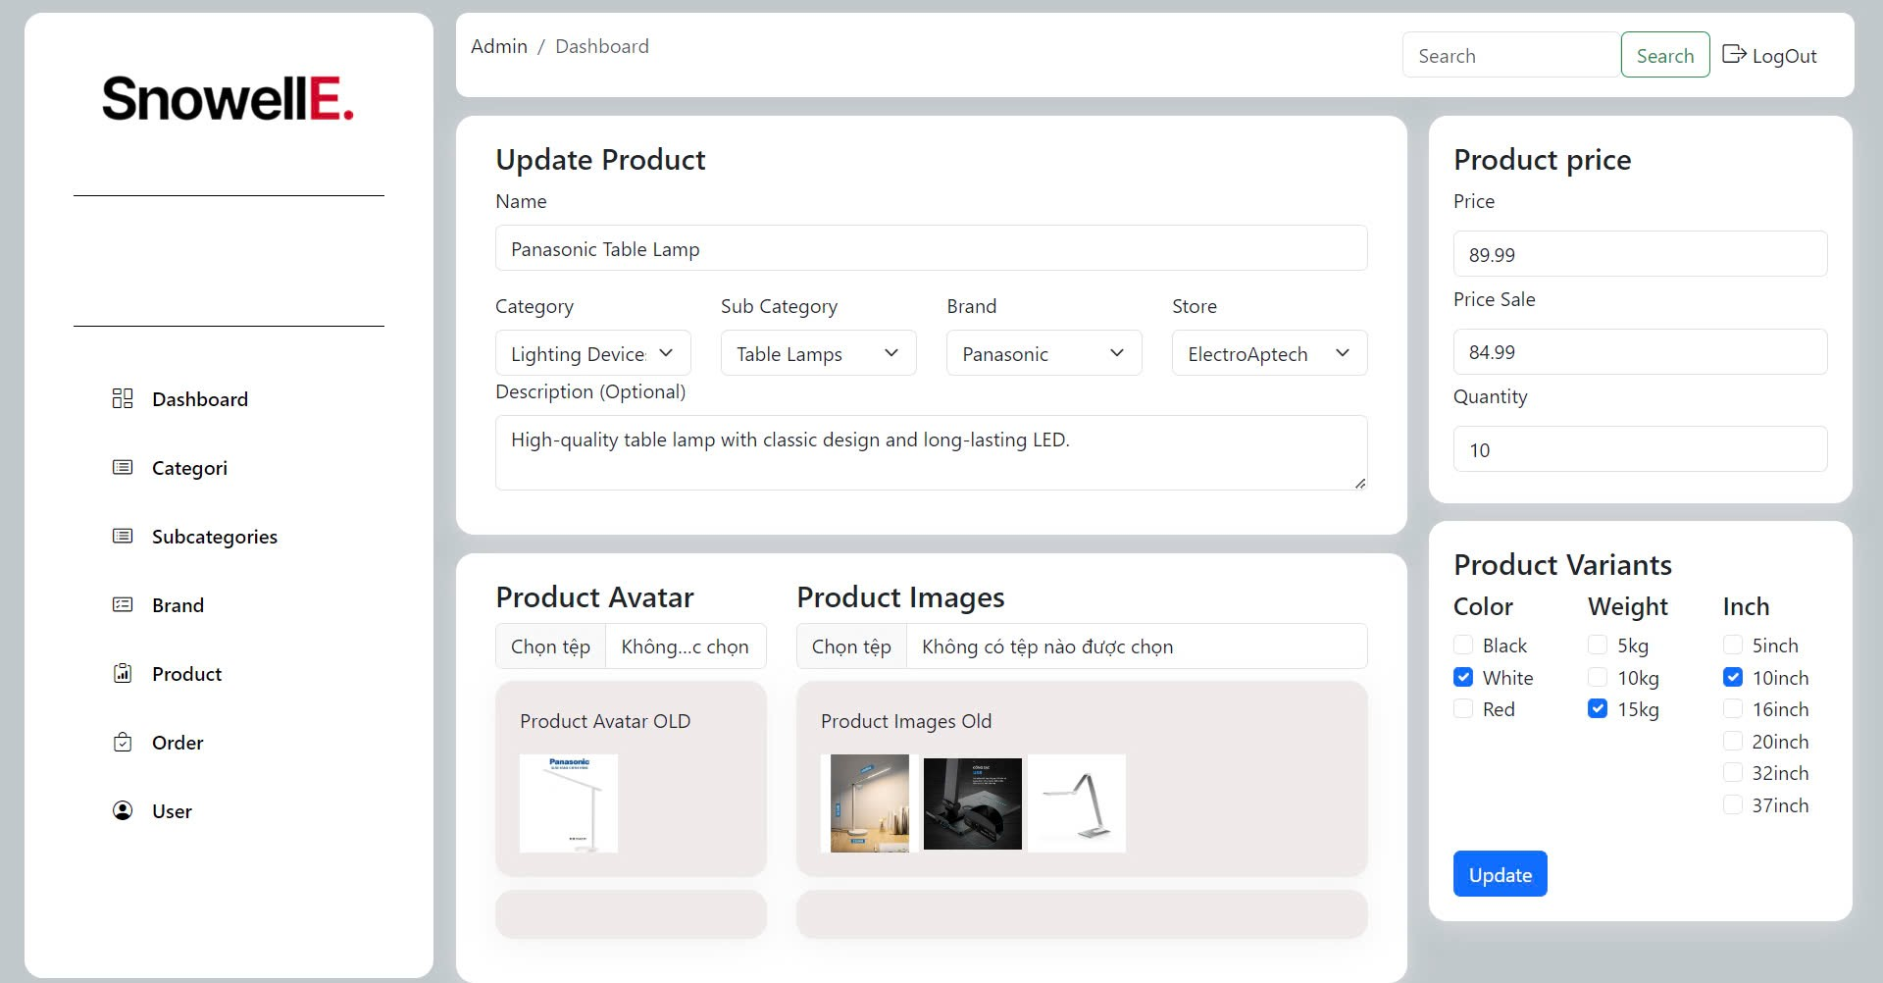

This interface shows:

**Update Product**:

**Name**: Input field to update the product name.

**Category**: Dropdown menu to select the main category.

**Sub Category**: Dropdown menu to select the subcategory.

**Brand**: Dropdown menu to select the brand.

**Store**: Dropdown menu to select the store.

**Description (Optional)**: Input field to add or update the product description.

***Product Avatar****:*

**Choose File**: Option to upload a new product avatar image.

**Product Avatar Old**: Display of the current product avatar image.

***Product Images****:*

**Choose File**: Option to upload new product images.

**Product Images Old**: Display of the current product images.

***Product Price****:*

**Price**: Input field to update the product price.

**Price Sale**: Input field to update the sale price.

**Quantity**: Input field to update the quantity available. ***Product Variants****:*

**Color**: Checkboxes to select available colors.

**Weight**: Checkboxes to select available weights.

**Inch**: Checkboxes to select available sizes.

**Update Button**: Button to save all changes.

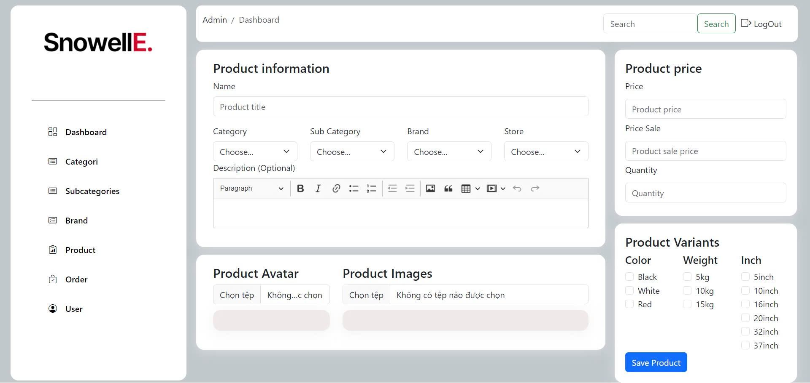

This interface shows:

**Product Information**:

**Name**: Input field for the product title.

**Category**: Dropdown menu to select the main category.

**Sub Category**: Dropdown menu to select the subcategory.

**Brand**: Dropdown menu to select the brand.

**Store**: Dropdown menu to select the store.

**Description (Optional)**: Input field for the product description with rich text formatting options.

**Save Product**:

**Save Product Button**: Button to save all product information and updates.

The same parts are also mentioned above.

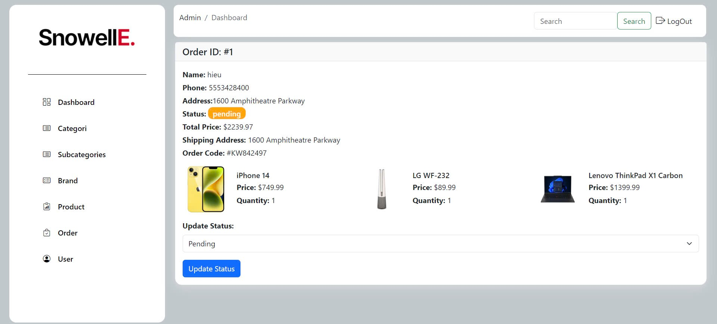

This interface shows:

***Order Details****:*

**Order ID**: Displays the order ID (e.g., #1).

**Customer Information**:

**Name**: Customer's name.

**Phone**: Customer's phone number.

**Address**: Customer's address.

***Order Status****:*

**Status**: Current order status (e.g., pending).

**Update Status**: Dropdown menu to change the order status.

**Update Status Button**: Button to save the status update.

***Order Summary****:*

**Total Price**: Total cost of the order.

**Shipping Address**: Address where the order will be shipped.

**Order Code**: Unique code for the order.

***Products Ordered****:*

**Product Details**: Displays each product's name, price, and quantity (Example products)

### 2.3.5. Logout

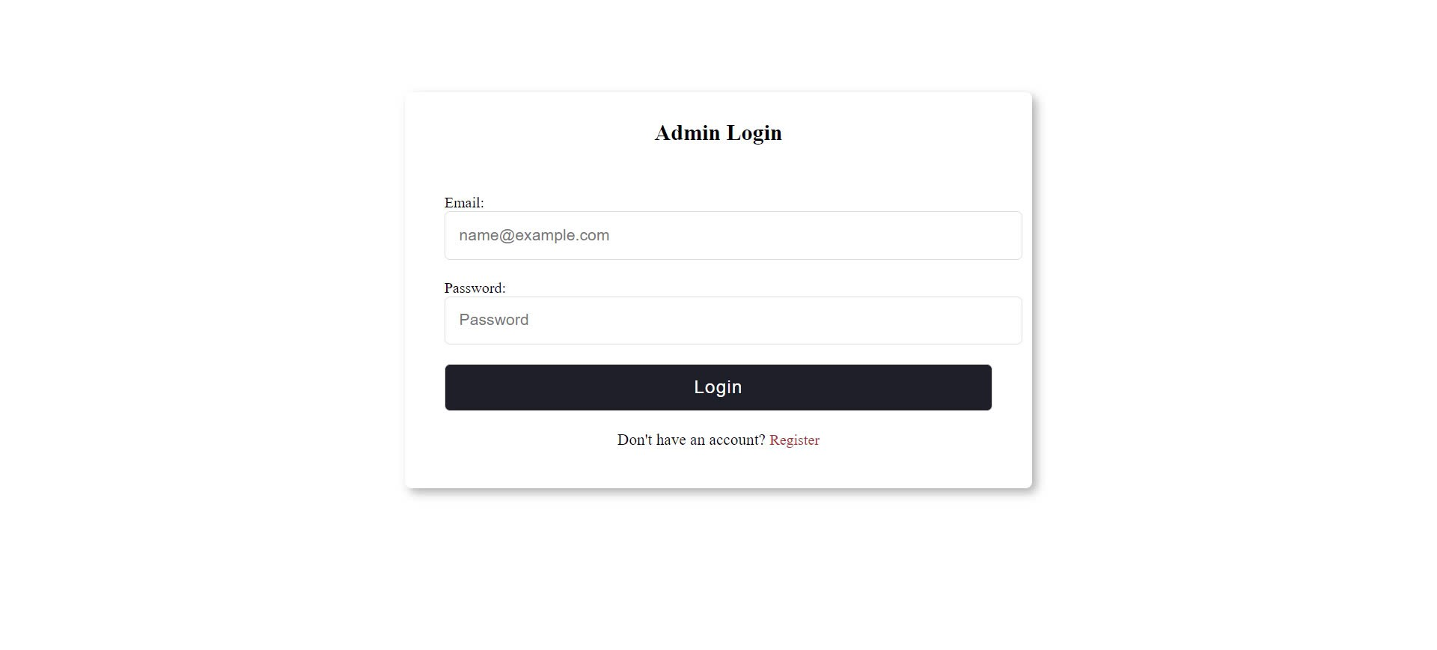

This interface shows:

**Admin Login**:

**Email**: Input field for the admin's email address.

**Password**: Input field for the admin's password.

**Login Button**: Button to submit the login credentials.

**Register Link**: Link to the registration page for new accounts.

# System Designs

## Entity Relationship Diagram

With the objective of creating a website that integrates information provision with e-commerce, we identify the entities that the website needs:

* Homepage:

- Header:

+ Search Bar

+ Cart

+ Login

- List categories Products

+ Consumer Electronic

+ Home Appliances

+ Cooling Devices

+ Audio Equipment

+ Lighting Devices

+ Store Address

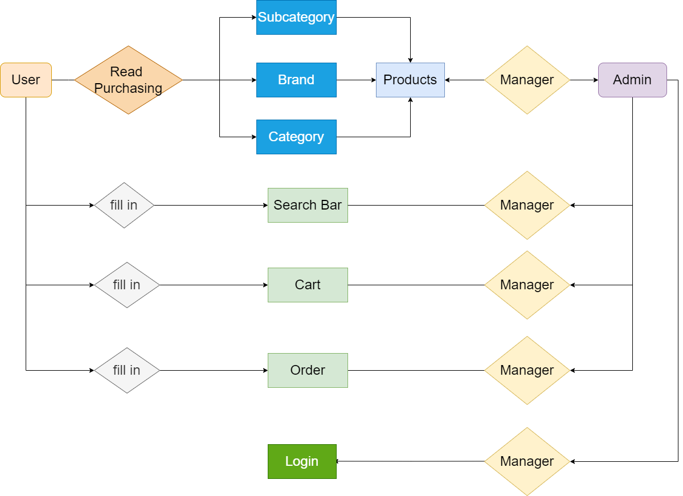

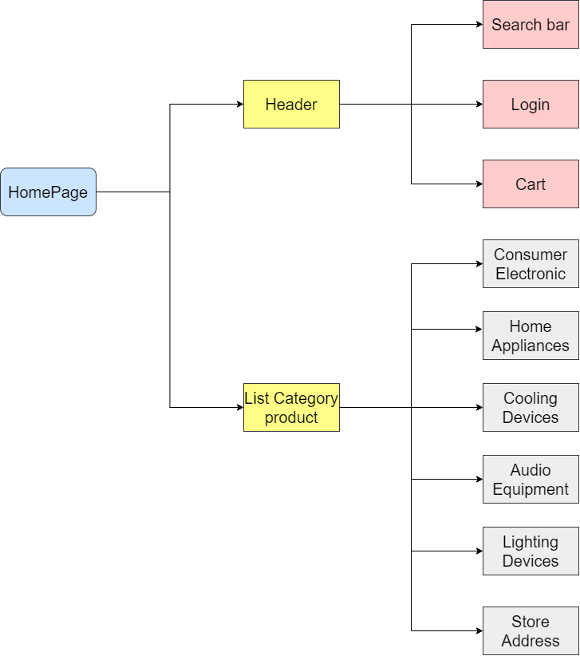

## Database Design

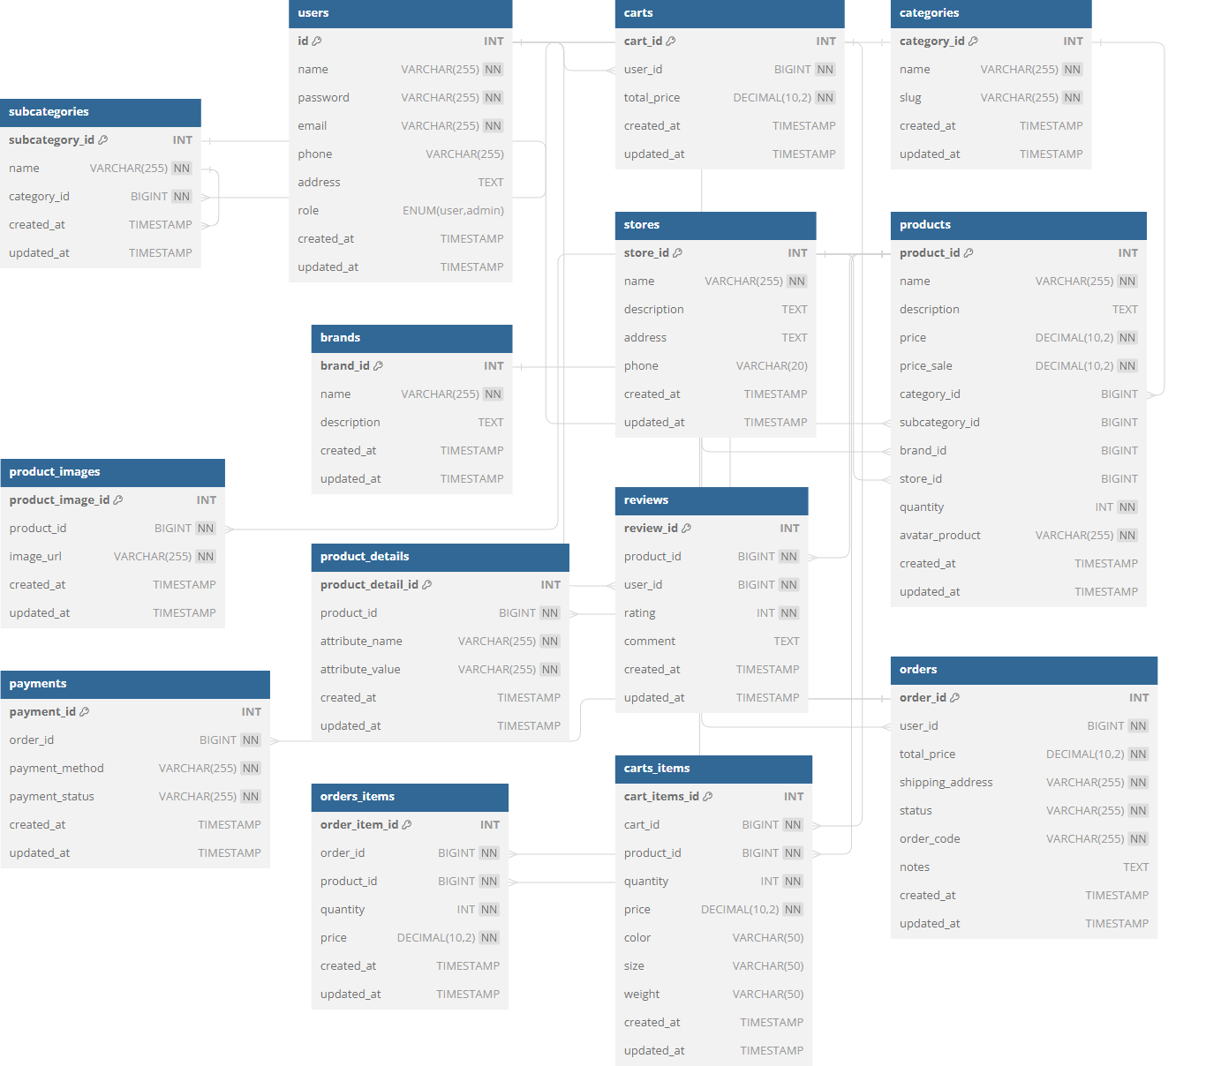

|  |  |  |
| --- | --- | --- |
| USER | | |
| FIELD | DATATYPE | CONSTRAINT |
| ID | INT | Primary Key, NOT NULL, auto increment |
| Name | VARCHAR(255) | NOT NULL |
| Password | VARCHAR(255) | NOT NULL |
| Email | VARCHAR(255) | NOT NULL |
| Phone | VARCHAR(255) |  |
| Address | TEXT |  |
| Role | ENUM |  |
| Create_at | TIMESTAMP |  |
| Update_at | TIMESTAMP |  |

|  |  |  |
| --- | --- | --- |
| STORES | | |
| FIELD | TYPE | CONSTRAINT |
| Stores_id | INT | Primary Key, NOT NULL, auto increment |
| Name | VARCHAR(255) | NOT NULL |
| Description | TEXT |  |
| Address | TEXT |  |
| Phone | VARCHAR(20) |  |
| Created_at | TIMESTAMP |  |
| Updated_at | TIMESTAMP |  |

|  |  |  |
| --- | --- | --- |
| BRANDS | | |
| FIELD | TYPE | CONSTRAINT |
| Brand_id | INT | Primary Key, NOT NULL, auto increment |
| Name | VARCHAR(255) | NOT NULL |
| Description | TEXT |  |
| Created_at | TIMESTAMP |  |
| Updated_at | TIMESTAMP |  |

|  |  |  |
| --- | --- | --- |
| PRODUCTS | | |
| FIELD | TYPE | CONSTRAINT |
| Product_id | INT | Primary Key, NOT NULL, auto increment |
| Name | VARCHAR(255) | NOT NULL |
| description | TEXT |  |
| Price | DECIMAL(10,2) | NOT NULL |
| Price_sale | DECIMAL(10,2) | NOT NULL |
| Category_id | BIGINT |  |
| Subcategory_id | BIGINT |  |
| Brand_id | BIGINT |  |
| Store_id | BIGINT |  |
| Quantity | INT | NOT NULL |
| Avatar_product | VARCHAR(255) | NOT NULL |
| Created_at | TIMESTAMP |  |
| Updated_at | TIMESTAMP |  |

|  |  |  |
| --- | --- | --- |
| CATEGORIES | | |
| FIELD | TYPE | CONSTRAINT |
| Category_id | INT | Primary Key, NOT NULL, auto increment |
| Name | VARCHAR(255) | NOT NULL |
| Slug | VARCHAR(255) | NOT NULL |
| Created_at | TIMESTAMP |  |
| Updated_at | TIMESTAMP |  |
| SUBCATEGORIES | | |
| FIELD | TYPE | CONSTRAINT |
| Subcategory_id | INT | Primary Key, NOT NULL, auto increment |
| Name | VARCHAR(255) | NOT NULL |
| Category_id | BIGINT | NOT NULL |
| Created_at | TIMESTAMP |  |
| Update_at | TIMESTAMP |  |

|  |  |  |
| --- | --- | --- |
| PRODUCT_IMAGES | | |
| FIELD | TYPE | CONSTRAINT |
| Product_image_id | INT | Primary Key, NOT NULL, auto increment |
| Product_id | BIGINT | NOT NULL |
| Image_url | VARCHAR(255) | NOT NULL |
| Created_at | TIMESTAMP |  |
| Update_at | TIMESTAMP |  |

|  |  |  |
| --- | --- | --- |
| PAYMENTS | | |
| FIELD | TYPE | CONSTRAINT |
| Payment_id | INT | Primary Key, NOT NULL, auto increment |
| Oder_id | BIGINT | NOT NULL |
| Payment_method | VARCHAR(255) | NOT NULL |
| Payment_status | VARCHAR(255) | NOT NULL |
| Created_at | TIMESTAMP |  |
| Update_at | TIMESTAMP |  |

|  |  |  |
| --- | --- | --- |
| PRODUCT_DETAILS | | |
| FIELD | TYPE | CONSTRAINT |
| Product_detail_id | INT | Primary Key, NOT NULL, auto increment |
| Product_id | BIGINT | NOT NULL |
| Attribute_name | VARCHAR(255) | NOT NULL |
| Attribute_value | VARCHAR(255) | NOT NULL |
| Created_at | TIMESTAMP |  |
| Update_at | TIMESTAMP |  |

|  |  |  |
| --- | --- | --- |
| ODERS_ITEMS | | |
| FIELD | TYPE | CONSTRAINT |
| Order_item_id | INT | Primary Key, NOT NULL, auto increment |
| Oder_id | BIGINT | NOT NULL |
| Product_id | BIGINT | NOT NULL |
| Quantity | INT | NOT NULL |
| Price | DECIMAL(10,2) | NOT NULL |
| Created_at | TIMESTAMP |  |
| Updated_at | TIMESTAMP |  |

|  |  |  |
| --- | --- | --- |
| CARTS | | |
| FIELD | TYPE | CONSTRAINT |
| Cart_id | INT | Primary Key, NOT NULL, auto increment |
| User_id | BIGINT | NOT NULL |
| Total_price | DECIMAL(10,2) | NOT NULL |
| Created_at | TIMESTAMP |  |
| Updated_at | TIMESTAMP |  |

|  |  |  |
| --- | --- | --- |
| REVIEWS | | |
| FIELD | TYPE | CONSTRAINT |
| Review_id | BIGINT | Primary Key, NOT NULL, auto increment |
| Product_id | BIGINT | NOTNULL |
| User_id | BIGINT | NOT NULL |
| Rating | INT | NOT NULL |
| Comment | TEXT |  |
| Created_at | TIMESTAMP |  |
| Updated_at | TIMESTAMP |  |

|  |  |  |
| --- | --- | --- |
| ORDERS | | |
| FIELD | TYPE | CONSTRAINT |
| Order_id | INT | Primary Key, NOT NULL, auto increment |
| User_id | BIGINT | NOT NULL |
| Total_price | DECIMAL(10,2) | NOT NULL |
| Shipping_address | VARCHAR(255) | NOT NULL |
| Status | VARCHAR(255) | NOT NULL |
| Order_code | VARCHAR(255) | NOT NULL |
| Notes | TEXT |  |
| Created_at | TIMESTAMP |  |
| Updated_at | TIMESTAMP |  |

|  |  |  |
| --- | --- | --- |
| CARTS_ITEMS | | |
| FIELD | TYPE | CONSTRAINT |
| ID | INT | Primary Key, NOT NULL, auto increment |
| Cart_id | BIGINT | NOT NULL |
| Product_id | BIGINT | NOT NULL |
| Quantity | INT | NOT NULL |
| Price | DECIMAL(10,2) | NOT NULL |
| Color | VARCHAR(50) |  |
| Size | VARCHAR(50) |  |
| Weight | VARCHAR(50) |  |
| Created_at | TIMESTAMP |  |
| Updated_at | TIMESTAMP |  |

## Sitemap

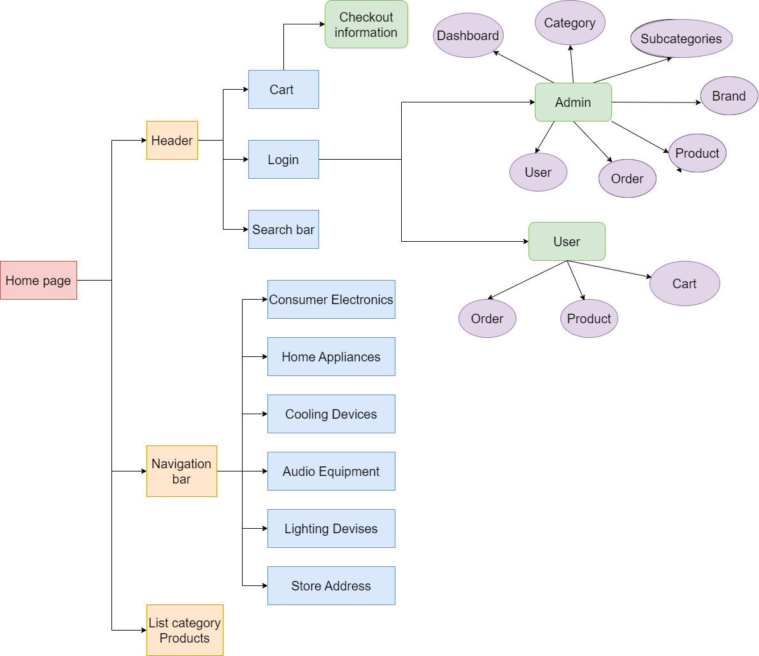

## System fucntions design

### 3.4.1. Resgistration

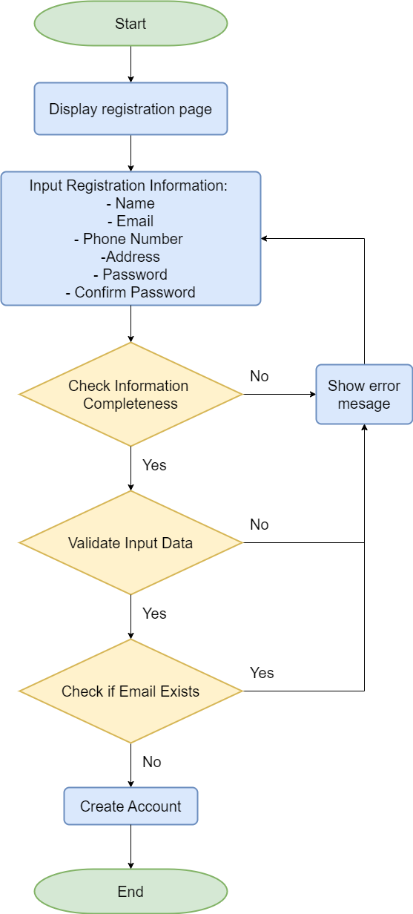

### 3.4.2. Login

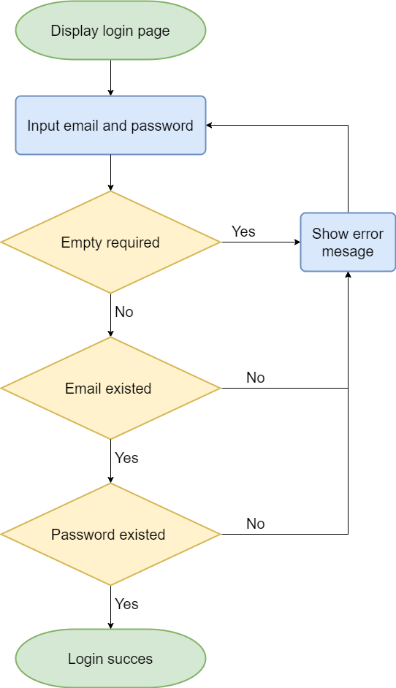

### 3.4.3. Checkout

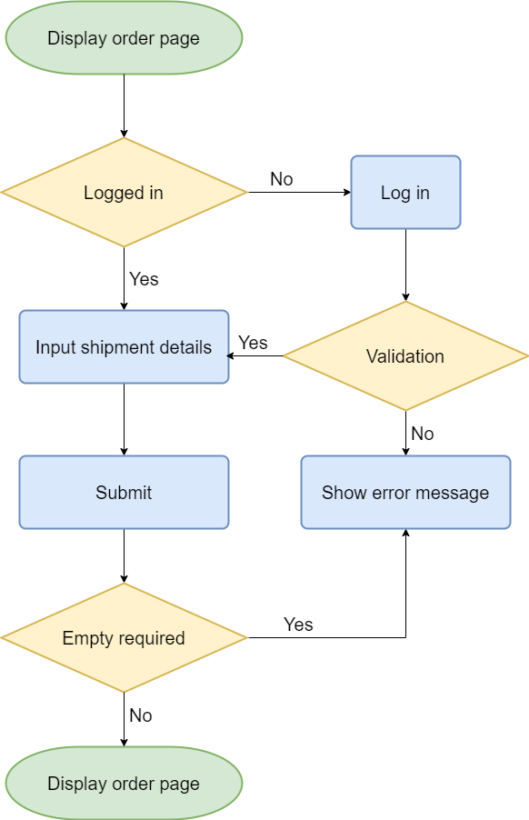

# Task sheet

|  |  |  |  |  |
| --- | --- | --- | --- | --- |
| **Task** | **Start Time** | **Finish Time** | **Implemented by** | **Evaluation (%)** |
| **0)Analyze tasks** | **17/07/2024** | **21/07/2024** | **Team** | **100** |
| Brainstorm the task | 17/07/2024 | 21/07/2024 | Hieu Phi Van | 100 |
| **I)Project Initialization** | **21/07/2024** | **25/07/2024** | **Team** | **100** |
| 1. Set Up Environtment   (install PHP, Laravel, ReactJS,git) | 21/07/2024 | 23/07/2024 | Dung Nguyen Duc | 33 |
| 1. Create Project Directory Structure, folder   (backend,frontend,database) | 21/07/2024 | 23/07/2024 | Hue Nguyen Thi | 33 |
| 1. Set Up Database   (Create tables, constraints,primarykey,foreign keys) | 23/07/2024 | 25/07/2024 | Hieu Tran The | 33 |
| **II) Backend Development(Laravel)**  **(Admin Dashboard,Api React)** | **25/07/2024** | **01/08/2024** | **Team** | **100** |
| **1.Admin Dashboard** | **25/07/2024** | **28/07/2024** | **Team** | **100** |
| a.1) Authentication & Authorization(backend) | 25/07/2024 | 26/07/2024 | Hieu Phi Van | 5 |
| a.2)Authentication & Authorization(frontend-view) | 26/07/2024 | 27/07/2024 | Hieu Phi Van | 5 |
| b.1) Category Management (backend) | 25/07/2024 | 26/07/2024 | Hieu Phi Van | 10 |
| b.2) Category Management (frontend-view) | 26/07/2024 | 27/07/2024 | Hieu Tran The | 5 |
| c.1) Subcategory anagement  (backend) | 25/07/2024 | 26/07/2024 | Hieu Phi Van | 10 |
| c.1) Subcategory anagement  (frontend-view) | 26/07/2024 | 27/07/2024 | Hue Nguyen Thi | 5 |
| d.1) Brand Management  (backend) | 25/07/2024 | 26/07/2024 | Hieu Phi Van | 10 |
| d.1) Brand Management  (frontend-view) | 26/07/2024 | 27/07/2024 | Dung Nguyen Duc | 5 |
| e.1) Product Management  (backend) | 25/07/2024 | 26/07/2024 | Hieu Phi Van | 10 |
| e.2) Product Management  (frontend-view) | 26/07/2024 | 27/07/2024 | Hieu Phi Van | 5 |
| f.1) Order Management  (backend) | 27/07/2024 | 28/07/2024 | Hieu Phi Van | 10 |
| f.2) Order Management  (frontend-view) | 27/07/2024 | 28/07/2024 | Hieu Phi Van | 5 |
| g.1) User Management  (backend) | 27/07/2024 | 28/07/2024 | Hieu Phi Van | 10 |
| g.1) User Management  (frontend-view) | 27/07/2024 | 28/07/2024 | Hieu Phi Van | 5 |
| **2.API REACT** | **28/07/2024** | **01/08/2024** | **Team** | **100** |
| a) Authentication & Authorization | 28/07/2024 | 30/08/2024 | Hieu Phi Van | 20 |
| b) Api Product Management | 28/07/2024 | 30/08/2024 | Hieu Phi Van | 20 |
| c) Api Category Management | 28/07/2024 | 30/08/2024 | Hieu Phi Van | 20 |
| d) Api Subcategory Management | 30/07/2024 | 01/08/2024 | Hieu Phi Van | 10 |
| e) Api Brand Management | 30/07/2024 | 01/08/2024 | Hieu Phi Van | 20 |
| f) Api Order Management | 30/07/2024 | 01/08/2024 | Hieu Phi Van | 10 |
| **III) Frontend Development(React)** | **01/08/2024** | **07/08/2024** | **Team** | **100** |
| a) Home page | 01/08/2024 | 03/08/2024 | Hieu Tran The | 10 |
| b) Shop page | 01/08/2024 | 04/08/2024 | Hieu Phi Van | 10 |
| c) Product page | 01/08/2024 | 05/08/2024 | Dung Nguyen Duc | 10 |
| d) Checkout page | 01/08/2024 | 05/08/2024 | Hue Nguyen Thi | 10 |
| e) Address page | 05/08/2024 | 06/08/2024 | Hue Nguyen Thi | 10 |
| f) Profile page | 06/08/2024 | 07/08/2024 | Dung Nguyen Duc | 10 |
| g) Thanksyou page | 07/08/2024 | 08/08/2024 | Hieu Tran The | 10 |
| h) Search page | 07/08/2024 | 08/08/2024 | Hieu Phi Van | 10 |
| i) Cart page | 07/08/2024 | 08/08/2024 | Hieu Tran The | 10 |
| k) Login,Register,Forgot page | 07/08/2024 | 08/08/2024 | Hieu Phi Van | 10 |
| **IV) Testing** | **07/08/2024** | **09/08/2024** | **Team** | **100** |
| Write test cases for backend (Laravel) | 07/08/2024 | 09/08/2024 | Hue Nguyen Thi | 33 |
| Write test cases for frontend (React) | 07/08/2024 | 08/08/2024 | Dung Nguyen Duc | 33 |
| Test integration between frontend and backend | 07/08/2024 | 09/08/2024 | Hieu Tran The | 33 |
| **V)Fìnd Assets** | **09/08/2024** | **10/08/2024** | **Team** | **100** |
| Image product | 09/08/2024 | 10/08/2024 | Hieu Tran The | 33 |
| Image product | 09/08/2024 | 10/08/2024 | Hue Nguyen Thi | 33 |
| Image product | 09/08/2024 | 10/08/2024 | Dung Nguyen Duc | 33 |
| **VI) Documentation & Report** | **10/08/2024** | **15/08/2024** | **Team** | **100** |
| a) Problem Definition | 10/08/2024 | 13/08/2024 | Hue Nguyen Thi | 20 |
| b) Customer Requirements | 10/08/2024 | 13/08/2024 | Dung Nguyen Duc | 20 |
| c.1) System Designs | 10/08/2024 | 13/08/2024 | Hieu Tran The | 20 |
| c.2) System Designs | 10/08/2024 | 13/08/2024 | Hue Nguyen Thi | 20 |
| d) Task sheet | 13/08/2024 | 15/08/2024 | Hieu Phi Van | 10 |
| e) Validation | 13/08/2024 | 15/08/2024 | Hieu Phi Van | 10 |

# Validation Checklists

Valiate data: register form – login form:

+register

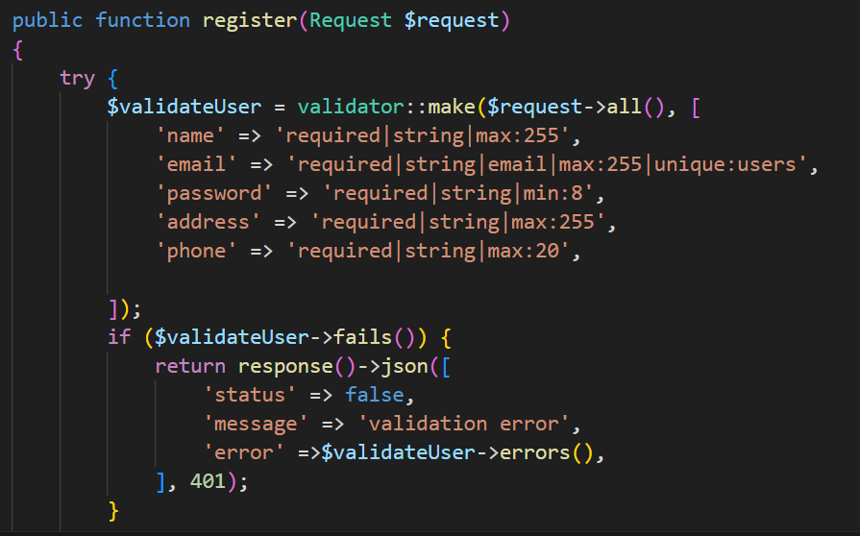

+ login

